# Task 01

## Data of denormalized table:

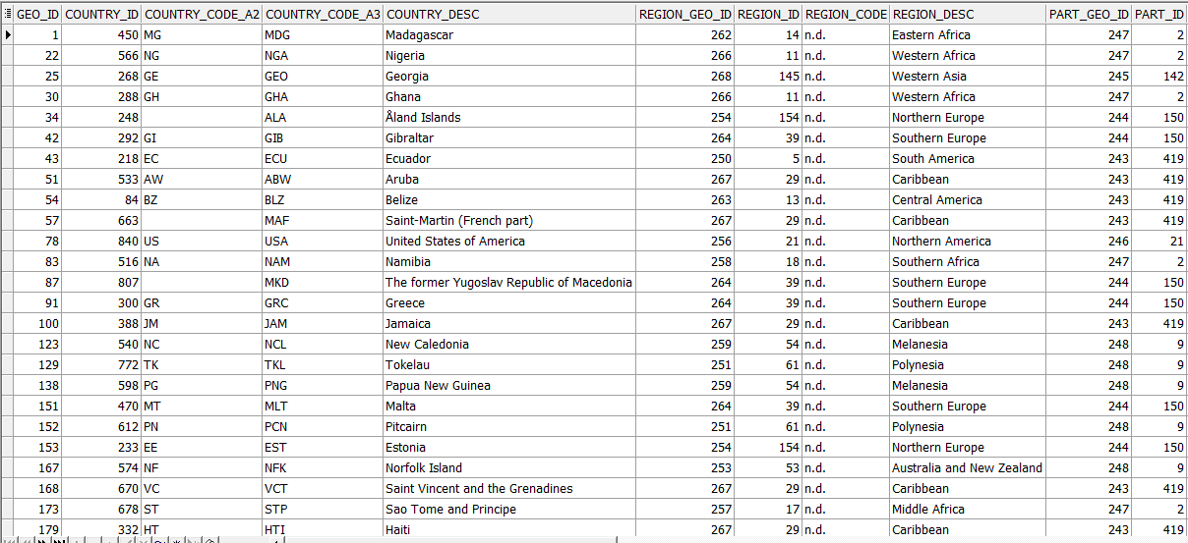

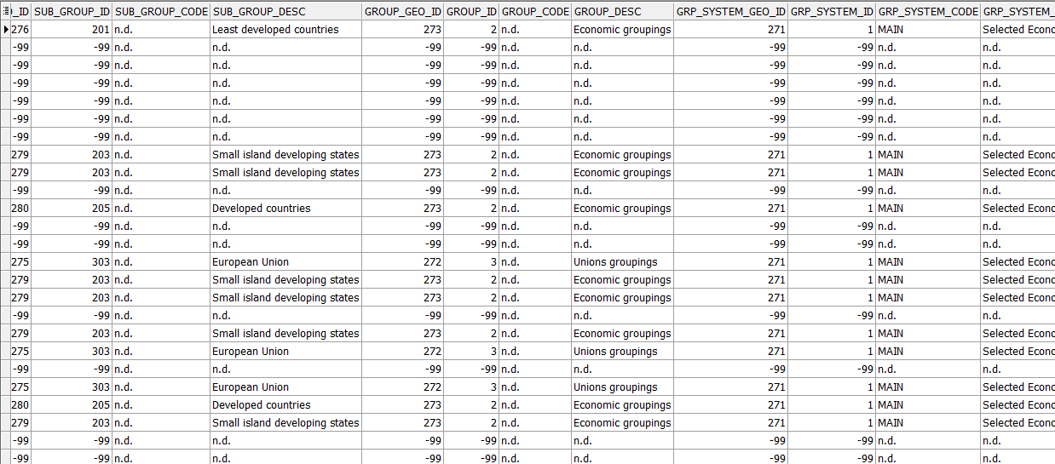

## Hierarchy with geo systems and country group systems as root elements.

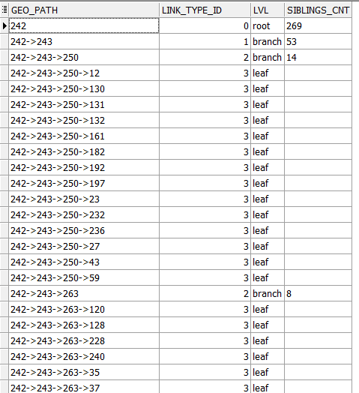

# Task 02

## Hierarch analysis of Geo Dimension

I choose all countries related to *Northern America* region using CONNECT BY. Then I joined result countries with TMP_ORDERS table and applied aggregation by country and delivery system.

